Hospital Website

Screenshots:

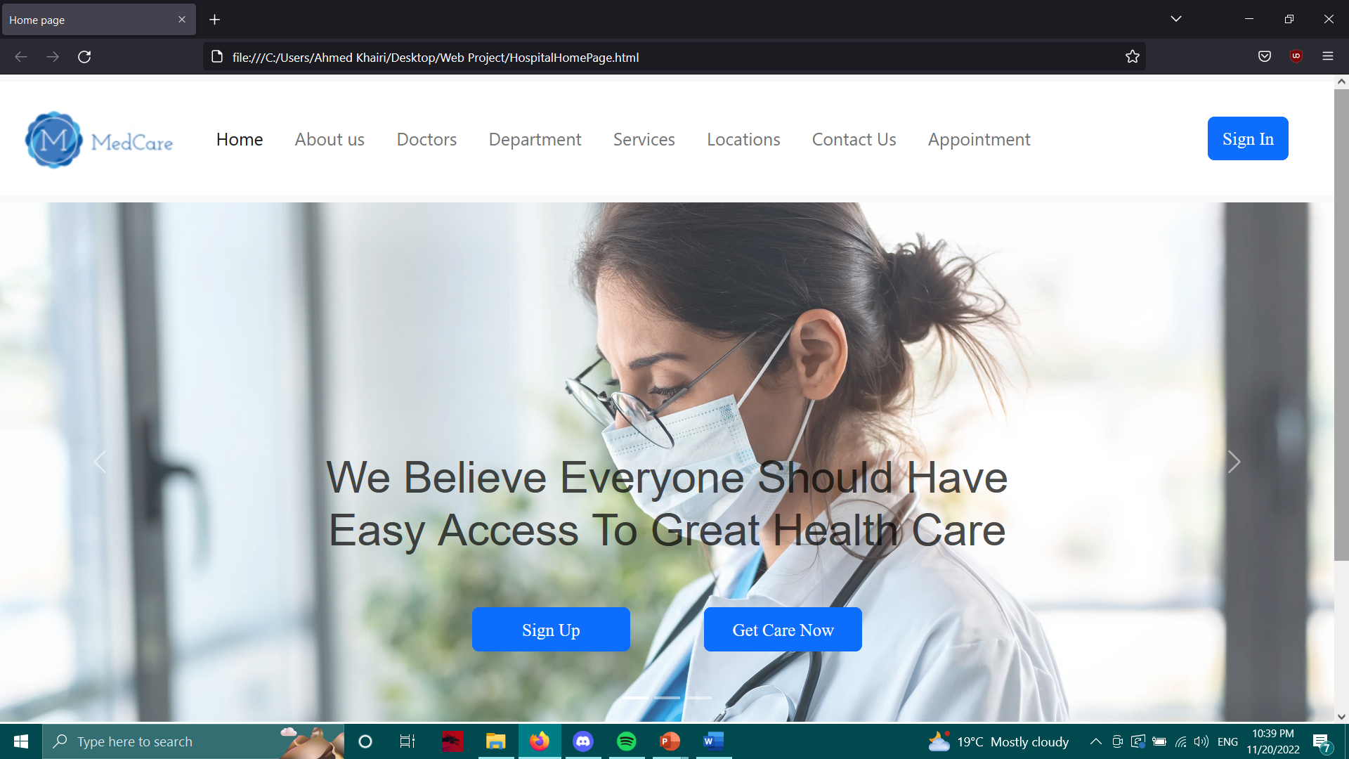

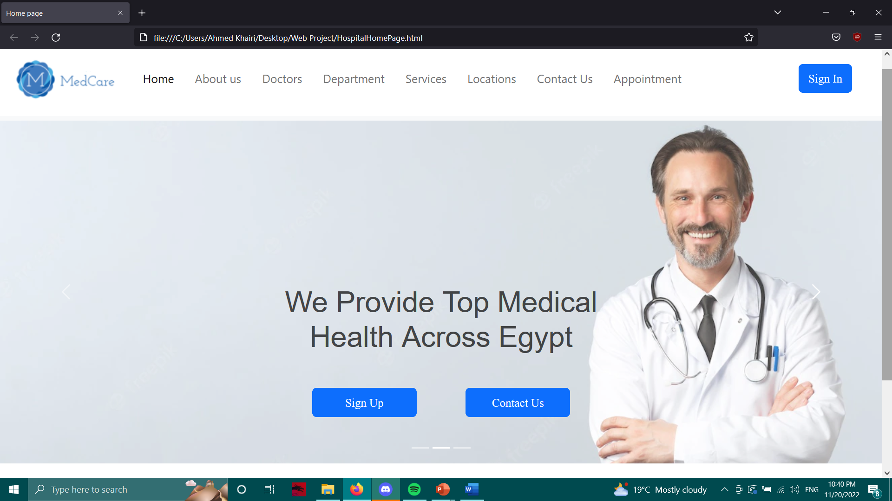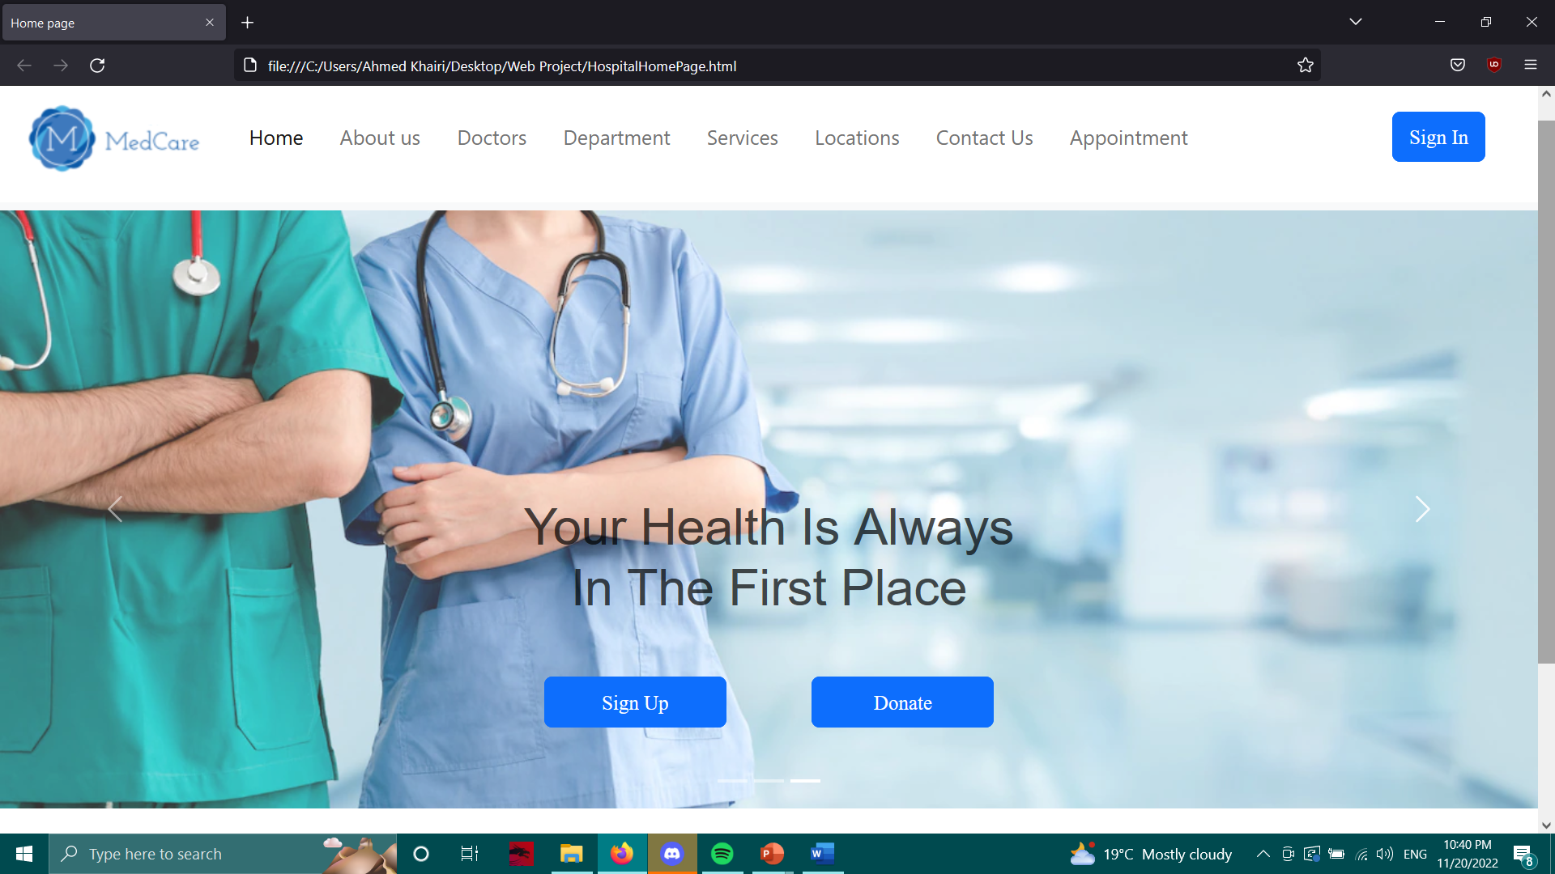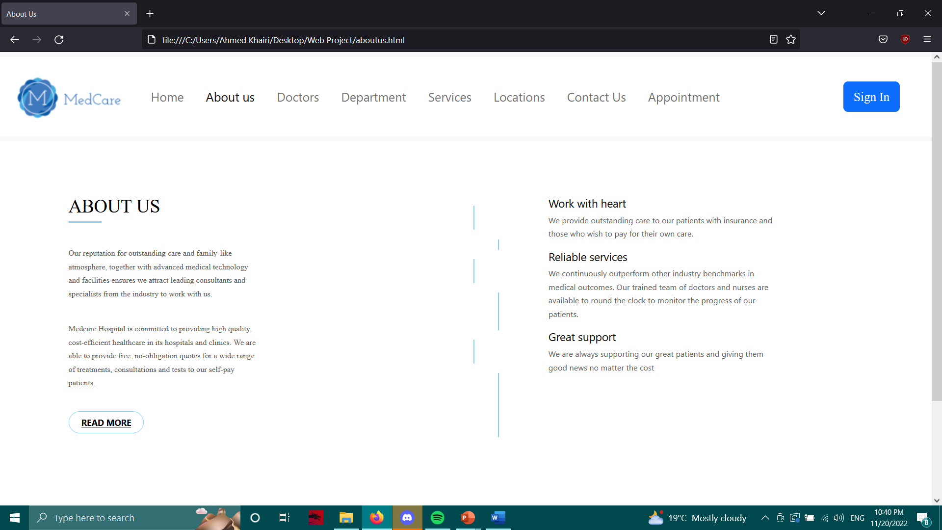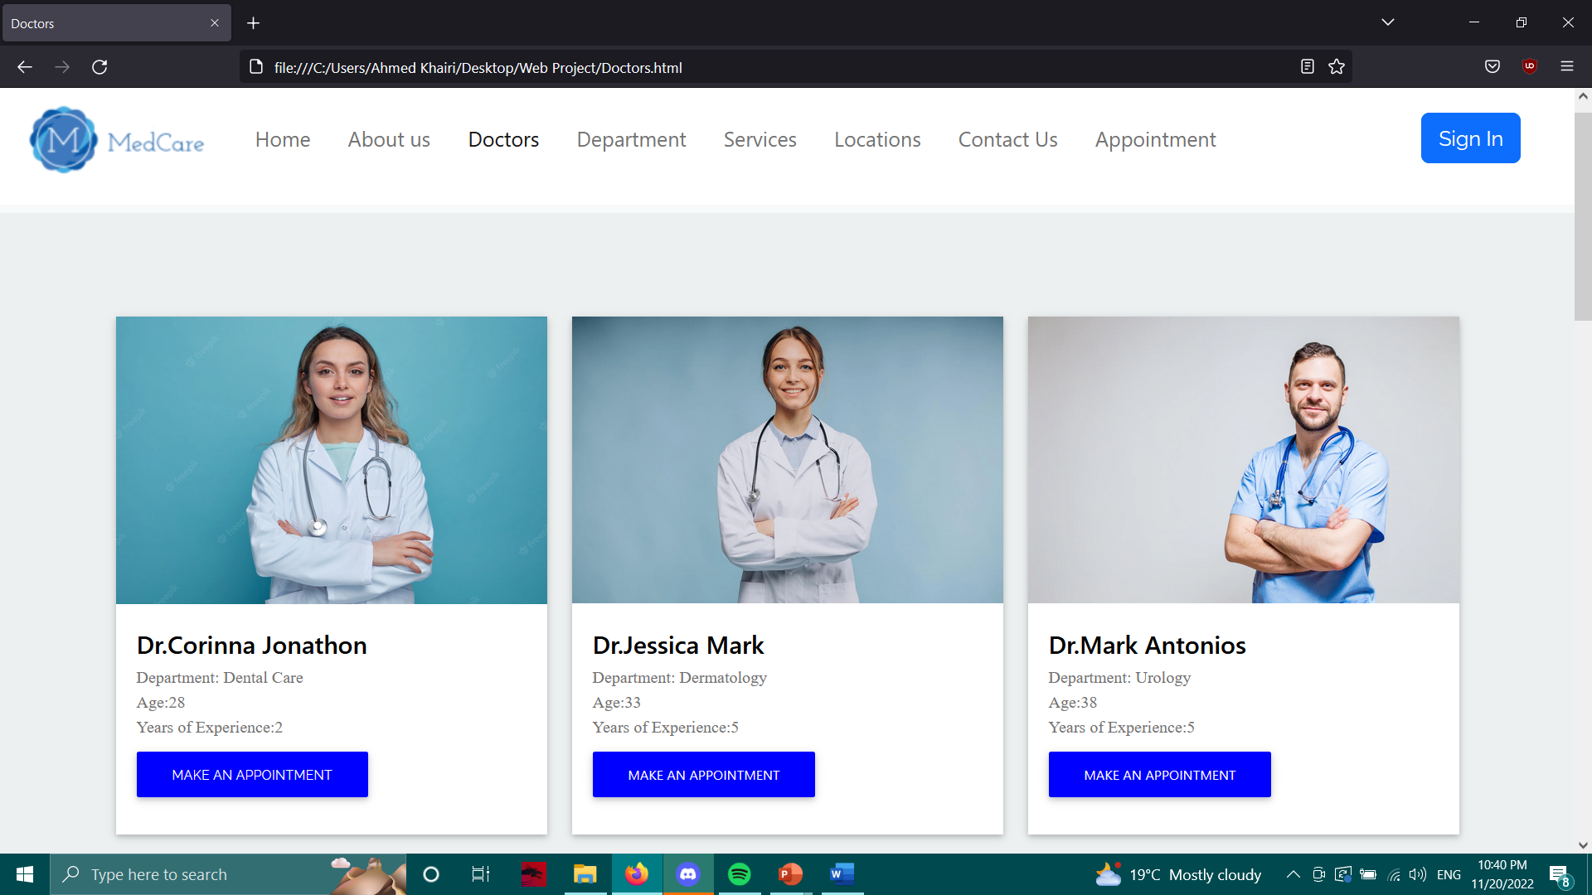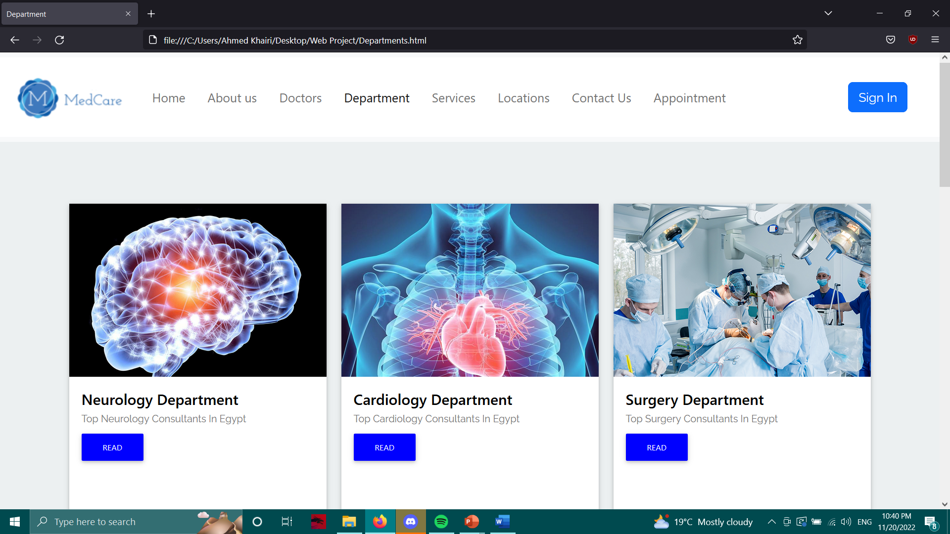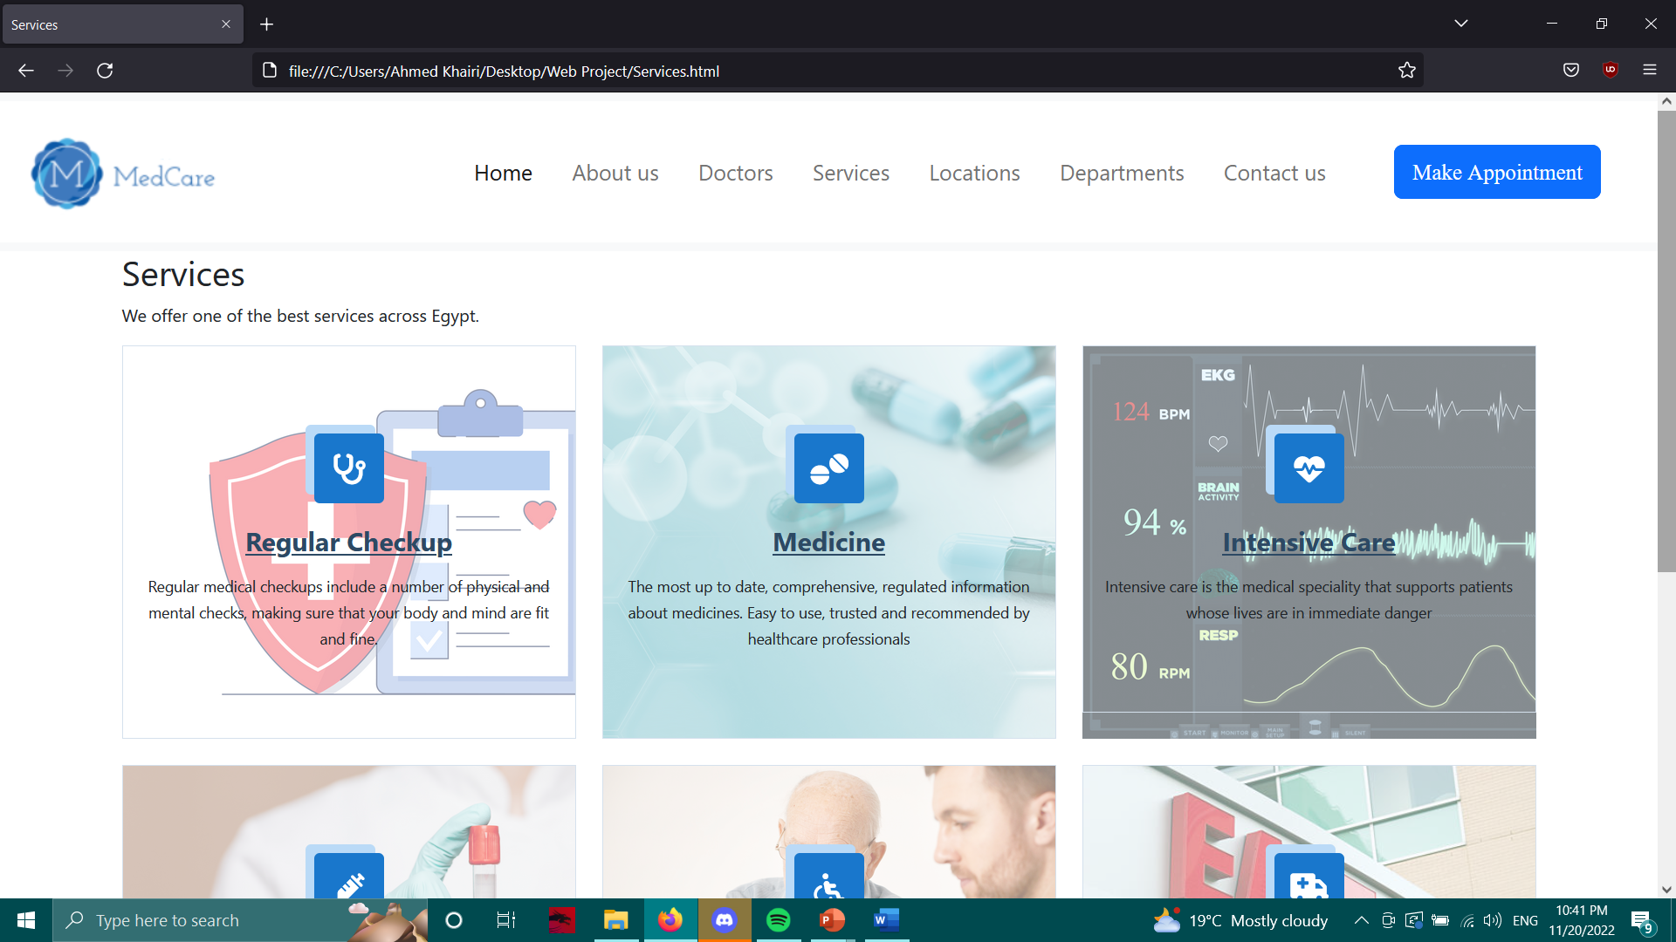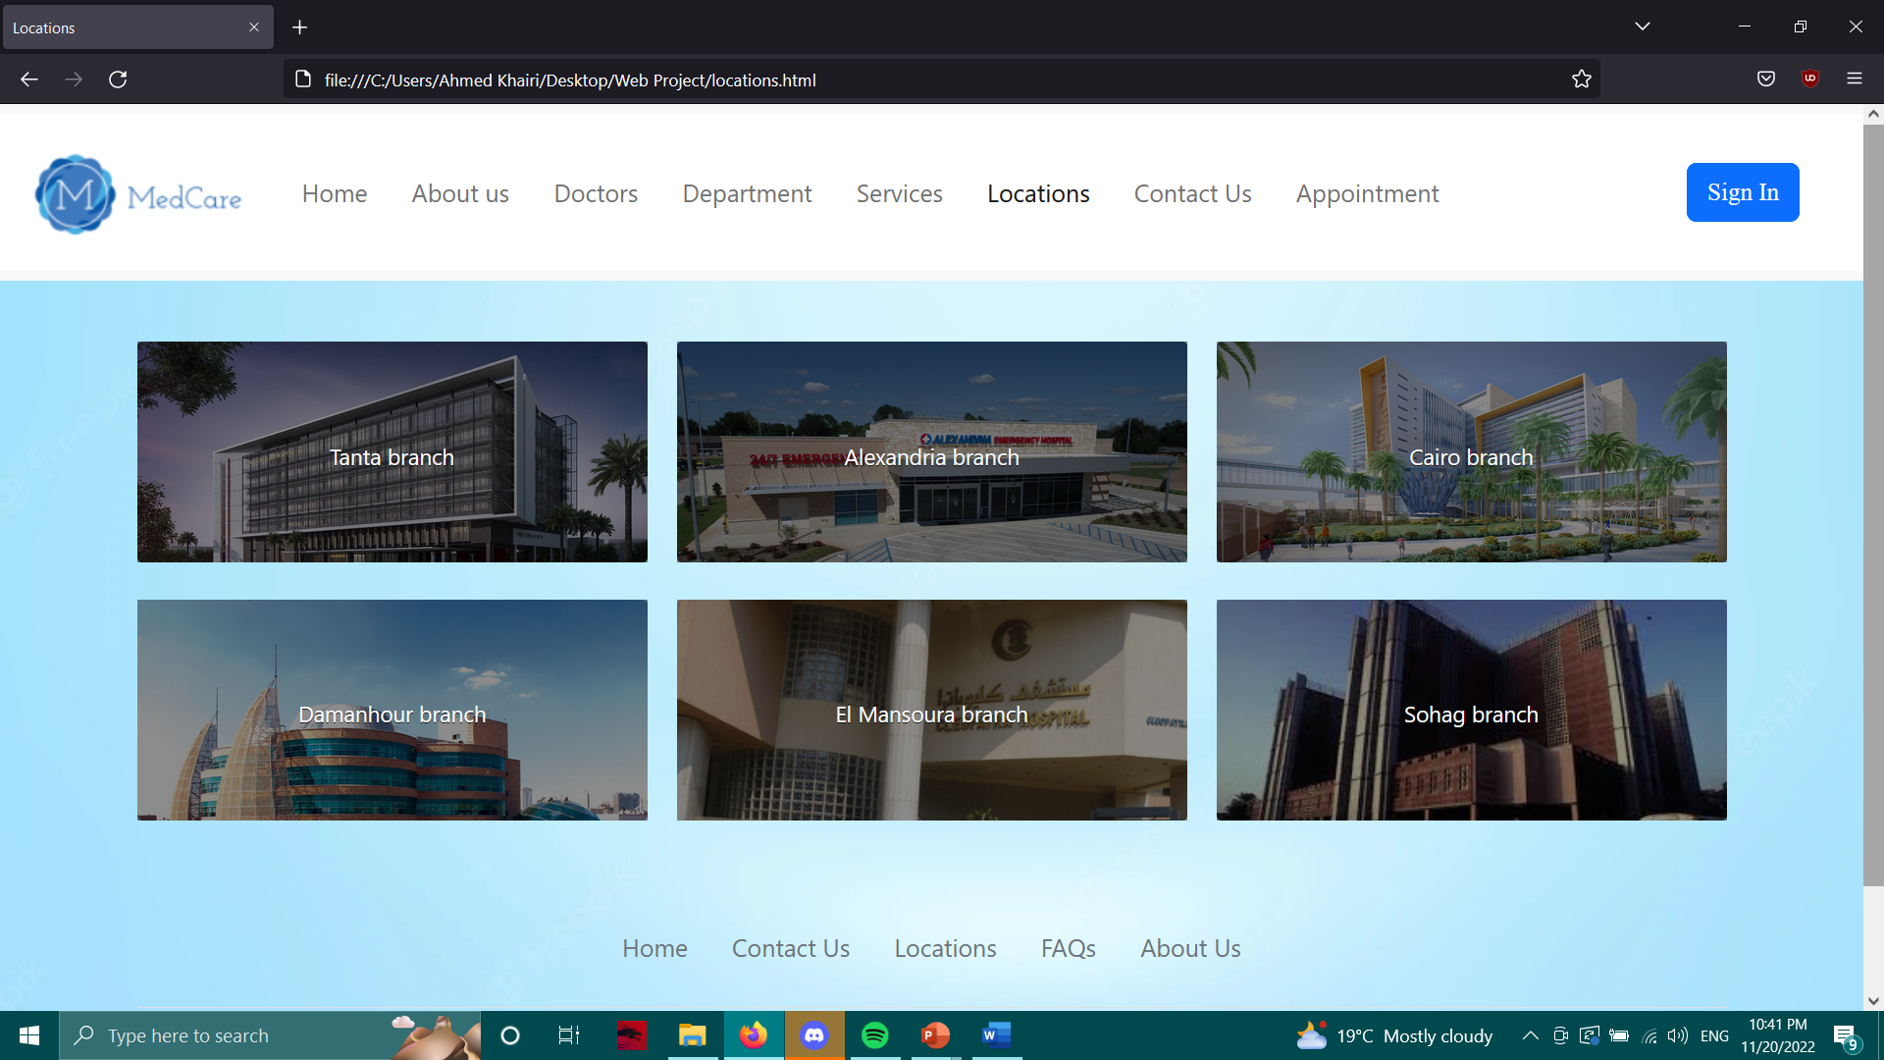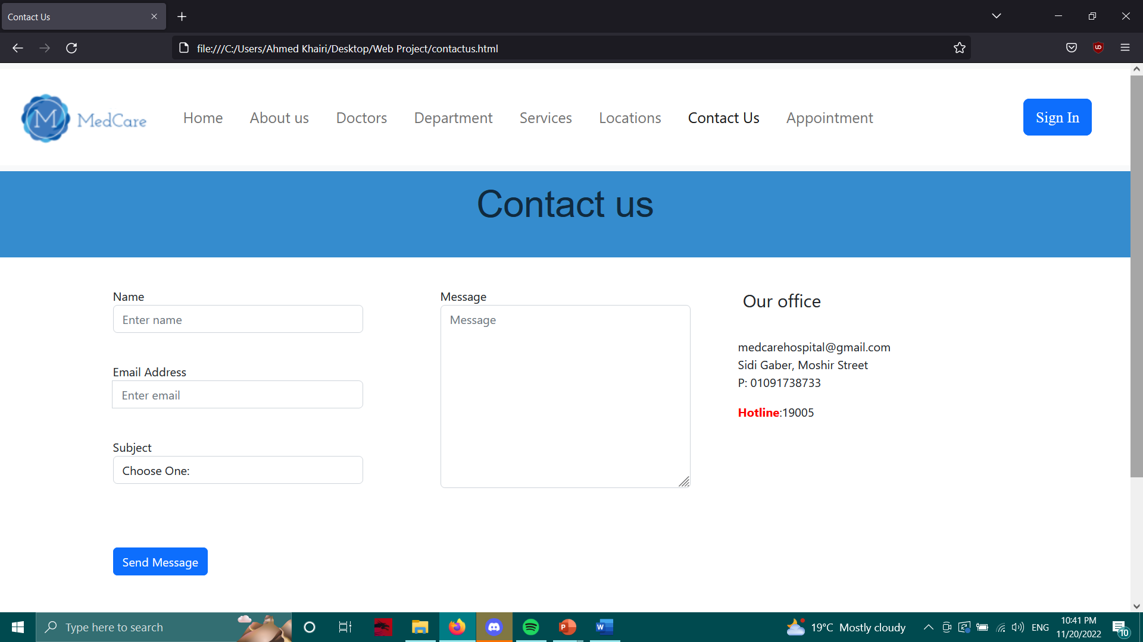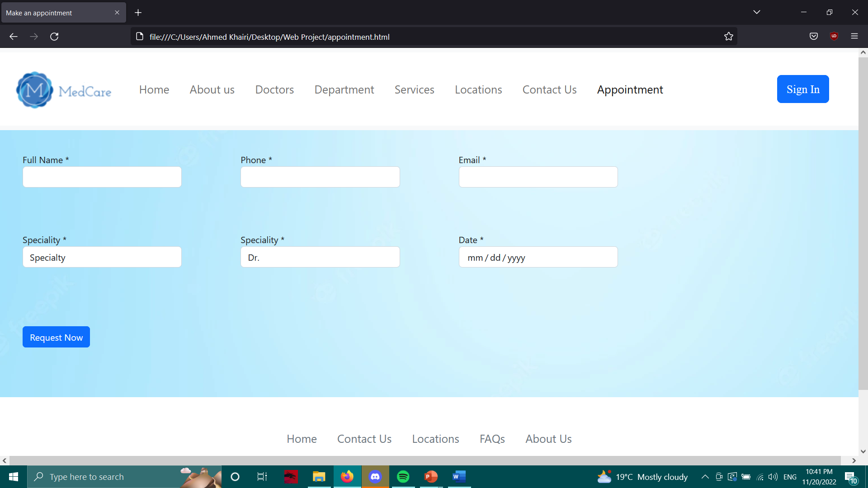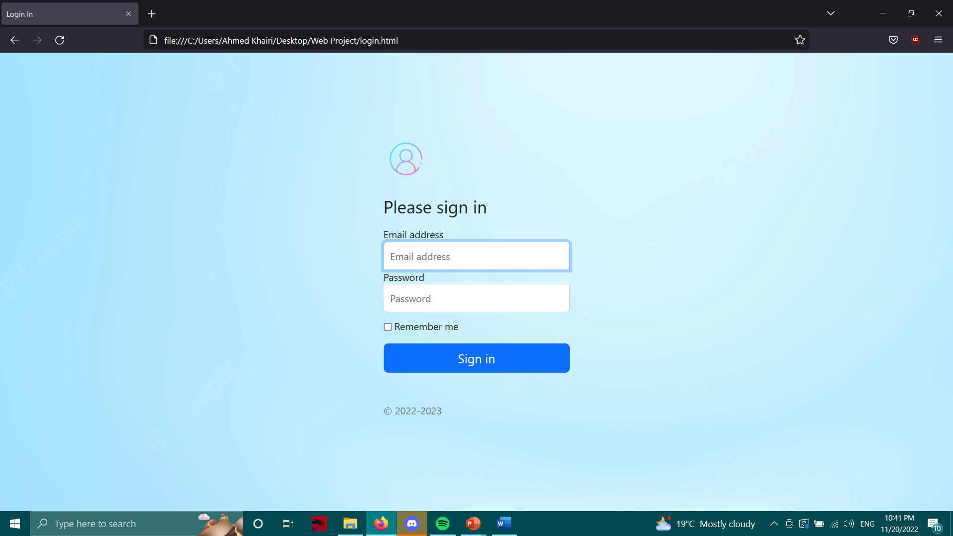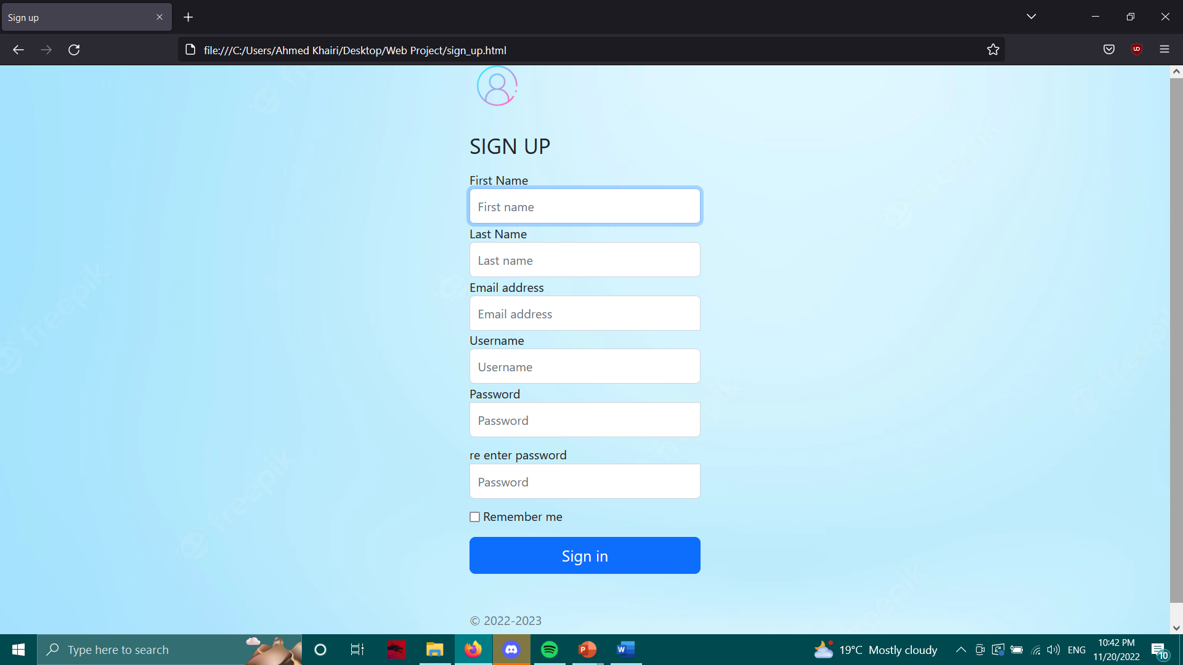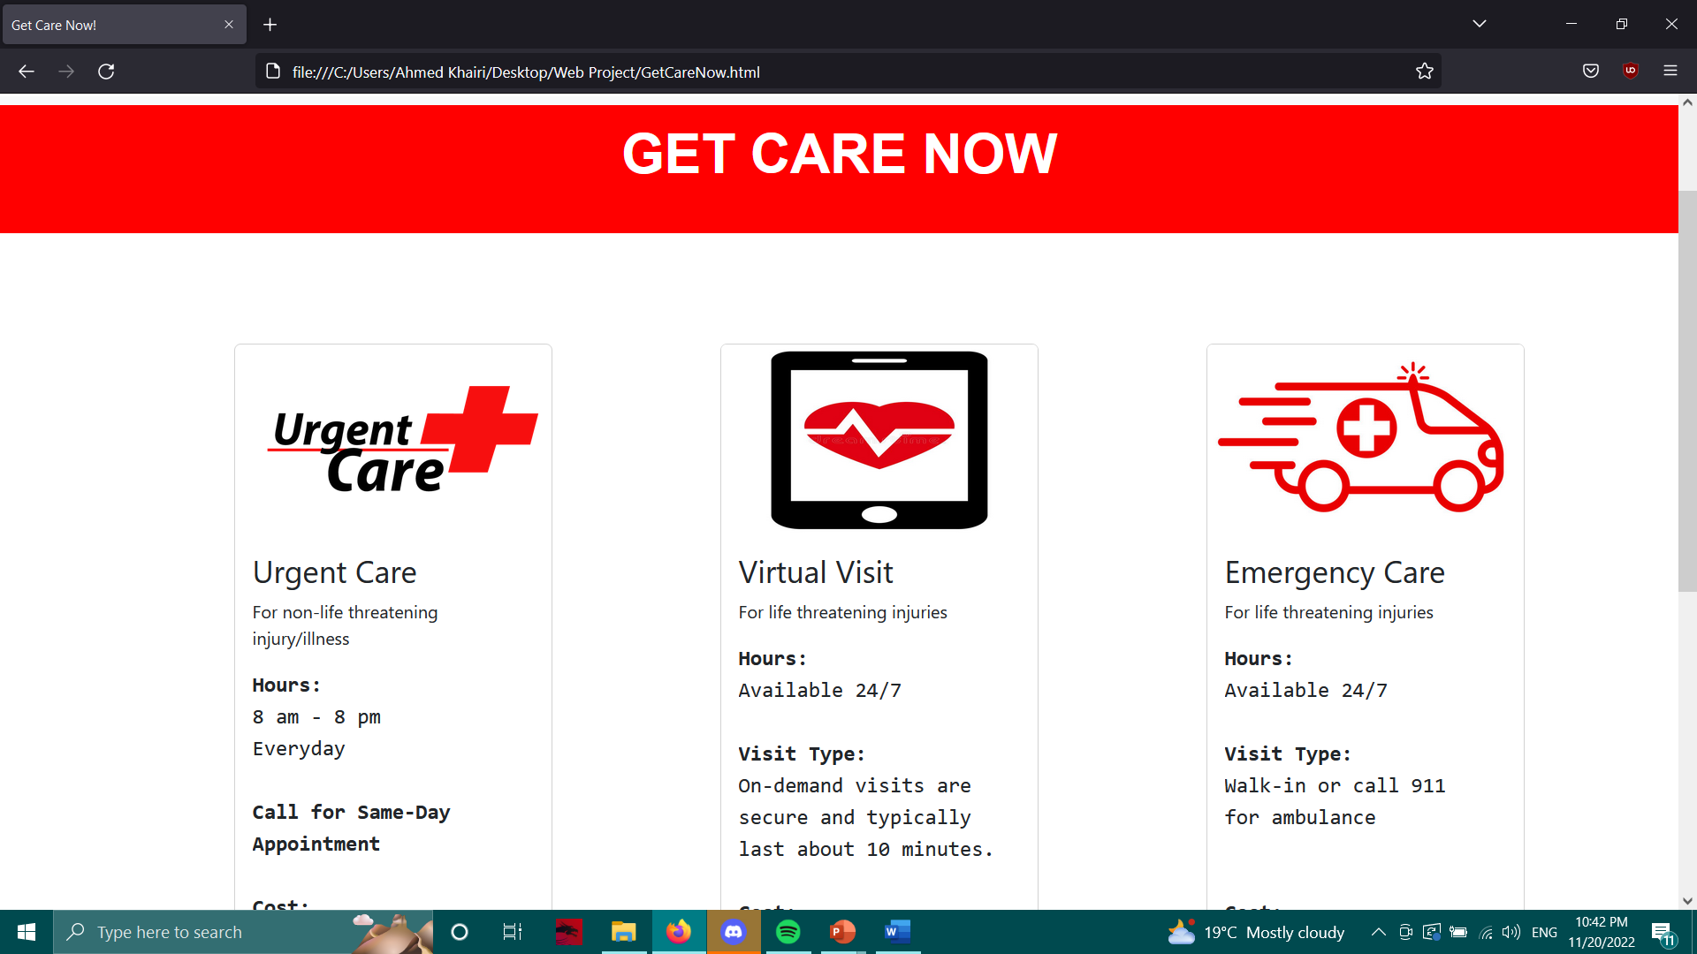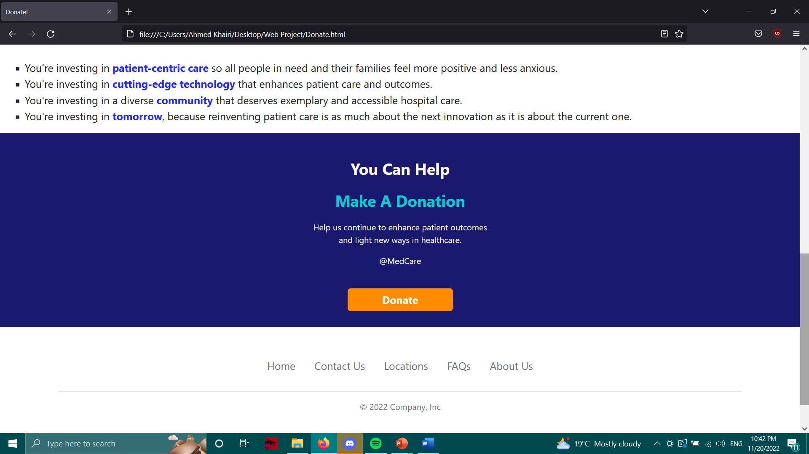

Goal:

Our website goal is to improve patient service, quality of care, staff retention. The manager can sign in using his unique account to manage employees. Also, our patients can sign in to our website to be able to search for their desired doctors according to their needs and health state. Our professional doctors are trained to provide the best possible treatment to our patients.

Work:

Ahmed Khairi Ahmed 19100561: Homepage, Doctors, About us

Zyad Shrin Allam 19103698: Get Care, Donations, Appointment

Sherif Khaled Wagih 19101205: Departments, Sign up, Locations

Loay Mohamed Gaber 19101664: Services, Sign in, Contact us